Reflect: In the Convolutional Implementation of Sliding Windows
VIDEO
Here FC layer is not FC layer, but indication that this is where "FC layer has been turned into convolutional layers"

REFERENCES:
Week 1:
- The Sequential model (TensorFlow Documentation)
- The Functional API (TensorFlow Documentation)
Week 2:
- Deep Residual Learning for Image Recognition (He, Zhang, Ren & Sun, 2015)
- deep-learning-models/resnet50.py/ (GitHub: fchollet)
- MobileNets: Efficient Convolutional Neural Networks for Mobile Vision Applications (Howard, Zhu, Chen, Kalenichenko, Wang, Weyand, Andreetto, & Adam, 2017)
- MobileNetV2: Inverted Residuals and Linear Bottlenecks (Sandler, Howard, Zhu, Zhmoginov &Chen, 2018)
- EfficientNet: Rethinking Model Scaling for Convolutional Neural Networks (Tan & Le, 2019)
Week 3:
- You Only Look Once: Unified, Real-Time Object Detection (Redmon, Divvala, Girshick & Farhadi, 2015)
- YOLO9000: Better, Faster, Stronger (Redmon & Farhadi, 2016)
- YAD2K (GitHub: allanzelener)
- YOLO: Real-Time Object Detection
- Fully Convolutional Architectures for Multi-Class Segmentation in Chest Radiographs (Novikov, Lenis, Major, Hladůvka, Wimmer & Bühler, 2017)
- Automatic Brain Tumor Detection and Segmentation Using U-Net Based Fully Convolutional Networks (Dong, Yang, Liu, Mo & Guo, 2017)
- U-Net: Convolutional Networks for Biomedical Image Segmentation (Ronneberger, Fischer & Brox, 2015)
Week 4:
- FaceNet: A Unified Embedding for Face Recognition and Clustering (Schroff, Kalenichenko & Philbin, 2015)
- DeepFace: Closing the Gap to Human-Level Performance in Face Verification (Taigman, Yang, Ranzato & Wolf)
- facenet (GitHub: davidsandberg)
- How to Develop a Face Recognition System Using FaceNet in Keras (Jason Brownlee, 2019)
- keras-facenet/notebook/tf_to_keras.ipynb (GitHub: nyoki-mtl)
- A Neural Algorithm of Artistic Style (Gatys, Ecker & Bethge, 2015)
- Convolutional neural networks for artistic style transfer
- TensorFlow Implementation of "A Neural Algorithm of Artistic Style"
- Very Deep Convolutional Networks For Large-Scale Image Recognition (Simonyan & Zisserman, 2015)

Week 1 QUIZ

1.
Question 1
What do you think applying this filter to a grayscale image will do?
$$\left[\begin{matrix}-1 & -1 & 2 \\ -1 & 2 & 1 \\ 2 & 1 & 1\end{matrix}\right]$$
Detect 45-degree edges.
Nice work
Correct. Notice that there is a high delta between the values in the top left part and the ones in the bottom right part. When convolving this filter on a grayscale image, the edges forming a 45-degree angle with the horizontal will be detected.
1 / 1 point

Question 2
Suppose your input is a 128 by 128 grayscale image, and you are not using a convolutional network. If the first hidden layer has 256 neurons, each one fully connected to the input, how many parameters does this hidden layer have (including the bias parameters)?
4194560
12583168
12582912
4194304
Try again
No, remember that a grayscale image has only one channel, not three.
0 / 1 point

Question 3
Suppose your input is a 300 by 300 color (RGB) image, and you use a convolutional layer with 100 filters that are each 5x5. How many parameters does this hidden layer have (including the bias parameters)?
7600
Nice work
Correct, you have $25×3=75$, weights and $1$ bias per filter. Given that you have 100 filters, you get 7,600 parameters for this layer.
1 / 1 point

Question 4
You have an input volume that is $121×121×16$ and convolve it with 32 filters of $4×4$, using a stride of 3 and no padding. What is the output volume?
$$40×40×32$$
Nice work
Correct, using the formula $n_{H}^{\left[l\right]}=\frac{n_{H}^{\left[l − 1\right]}+2×p-f}{s}+1$ with $n_{H}^{\left[l − 1\right]}=121$, $p=0$, $f=4$ and $s=3$ get 40
1 / 1 point

Question 5
You have an input volume that is 15x15x8, and pad it using “pad=2”. What is the dimension of the resulting volume (after padding)?
19x19x8
Nice work
Correct, padding is applied over the height and the width of the input image. If the padding is two, you add 4 to the height dimension and 4 to the width dimension.
1 / 1 point

Question 6
You have an input volume that is 63x63x16, and convolve it with 32 filters that are each 7x7, and stride of 1. You want to use a “same” convolution. What is the padding?
3
Nice work
Correct, you need to satisfy the following equation: $n_{H}-f+2×p+1=n_{H}$ as you want to keep the dimensions between the input volume and the output volume.
1 / 1 point

Question 7
You have an input volume that is 66x66x21, and apply max pooling with a stride of 3 and a filter size of 3. What is the output volume?
$$22×22×21$$
Nice work
Yes, using the formula $n_{H}^{\left[l\right]}=\frac{n_{H}^{\left[l − 1\right]}+2×p-f}{s}+1$ with $p=0$, $f=3$, $s=3$ and $n_{H}^{\left[l − 1\right]}=66$
1 / 1 point

Question 8
Which of the following are hyperparameters of the pooling layers? (Choose all that apply)
Filter size.
Nice work
Yes, although usually, we set $f=s$ this is one of the hyperparameters of a pooling layer.
Whether it is max or average.
Nice work
Yes, these are the two types of pooling discussed in the lectures, and choosing which to use is considered a hyperparameter.
1 / 1 point

Question 9
Which of the following are the benefits of using convolutional layers? (Check all that apply)
Convolutional layers are good at capturing translation invariance.
Nice work
Yes, this is due in part to applying the same filter all over the image.
It reduces the total number of parameters, thus reducing overfitting through parameter sharing.
Nice work
Yes, a convolutional layer uses parameters sharing and has usually a lot fewer parameters than a fully-connected layer.
1 / 1 point

Question 10
The sparsity of connections and weight sharing are mechanisms that allow us to use fewer parameters in a convolutional layer making it possible to train a network with smaller training sets. True/False?
True

Nice work
Yes, weight sharing reduces significantly the number of parameters in a neural network, and sparsity of connections allows us to use a smaller number of inputs thus reducing even further the number of parameters.

WEEK 2 QUIZ
Question 1
When building a ConvNet, typically you start with some POOL layers followed by some CONV layers. True/False?
False
Nice work
Correct. It is typical for ConvNets to use a POOL layer after some Conv layers; sometimes even one POOL layer after each CONV layer; but is not common to start with POOL layers.
1 / 1 point

2.
Question 2
In order to be able to build very deep networks, we usually only use pooling layers to downsize the height/width of the activation volumes while convolutions are used with “valid” padding. Otherwise, we would downsize the input of the model too quickly.
False
Nice work
Correct!
1 / 1 point

Question 3
The motivation of Residual Networks is that very deep networks are so good at fitting complex functions that when training them we almost always overfit the training data. True/False?
False

Nice work
Correct, very deep neural networks are hard to train and a deeper network does not always imply lower training error. Residual Networks allow us to train very deep neural networks.
1 / 1 point

Question 4
The computation of a ResNet block is expressed in the equation:
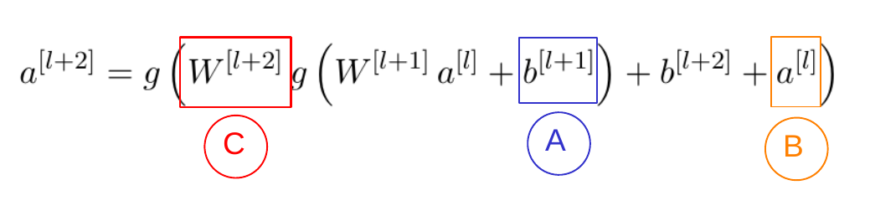
Which part corresponds to the skip connection?
The term in the orange box, marked as $B$.
Nice work
Yes, this term is the result of the skip connection or shortcut.
1 / 1 point

5.
Question 5
Adding a ResNet block to the end of a network makes it deeper. Which of the following is true?
The performance of the networks doesn't get hurt since the ResNet block can easily approximate the identity function.
Nice work
Yes, as noted in the lectures in a ResNet block the computations are given by $a^{\left[l + 2\right]}=g(W^{\left[l + 2\right]}a^{\left[l + 1\right]}+b^{\left[l + 2\right]}+a^{\left[l\right]})$ thus if $W^{\left[l + 2\right]}$ and $b^{\left[l + 2\right]}$ are zero then we get the identity function.
1 / 1 point

Question 6
$1×1$ convolutions are the same as multiplying by a single number. True/False?
False

Nice work
Yes, a $1×1$ layer doesn't act as a single number because it makes a sum over the depth of the volume.
1 / 1 point

Question 7
Which of the following are true about bottleneck layers? (Check all that apply)
By adding these layers we can reduce the computational cost in the inception modules.
Nice work
Yes, by using the $1×1$ convolutional layers we can reduce the depth of the volume and help reduce the computational cost of applying other convolutional layers with different filter sizes.
The use of bottlenecks doesn't seem to hurt the performance of the network.
Nice work
Yes, although it reduces the computational cost significantly.
1 / 1 point

Question 8
Models trained for one computer vision task can't be used directly in another task. In most cases, we must change the softmax layer, or the last layers of the model and re-train for the new task. True/False?
True
Nice work
Yes, this is a good way to take advantage of open-source models trained more or less for the task you want to do. This may also help you save a great number of computational resources and data.
1 / 1 point

9.
Question 9
Which of the following are true about Depthwise-separable convolutions? (Choose all that apply)
The pointwise convolution convolves the output volume with $1×1$ filters.
Nice work
Yes, the number of filters for the output of the depthwise-separable convolution is determined by the number of $1×1$ filters used.
Depthwise-separable convolutions are composed of two different types of convolutions.
Nice work
Yes, it is composed of a depthwise convolution followed by a pointwise convolution.
The depthwise convolution convolves each channel in the input volume with a separate filter.
Nice work
Yes, the output of this kind of convolution is the same as the input.
1 / 1 point

Question 10
Suppose that in a MobileNet v2 Bottleneck block we have an $n×n×5$ input volume, we use $30$ filters for the expansion, in the depthwise convolutions we use $3×3$ and 20 filters for the projection. How many parameters are used in the complete block, suppose we don't use bias?
1020
Nice work
Yes, the expansion filters use $5×30=$150 parameters, the depthwise convolutions need $3×3×30=270$ parameters, and the projection part $30×20=$600 parameters.

WEEK 3 QUIZ
Question 1
You are building a 3-class object classification and localization algorithm. The classes are: pedestrian (c=1), car (c=2), motorcycle (c=3). What should $y$ be for the image below? Remember that “?” means “don’t care”, which means that the neural network loss function won’t care what the neural network gives for that component of the output. Recall $y=[p_{c},b_{x},b_{y},b_{h},b_{w},c_{1},c_{2},c_{3}]$.
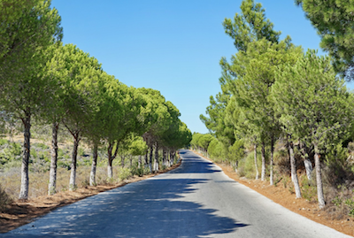
$$y=[0,?,?,?,?,?,?,?]$$
Nice work
Correct.
1 / 1 point

Question 2
You are working on a factory automation task. Your system will see a can of soft-drink coming down a conveyor belt, and you want it to take a picture and decide whether (i) there is a soft-drink can in the image, and if so (ii) its bounding box. Since the soft-drink can is round, the bounding box is always square, and the soft-drink can always appear the same size in the image. There is at most one soft-drink can in each image. Here are some typical images in your training set:
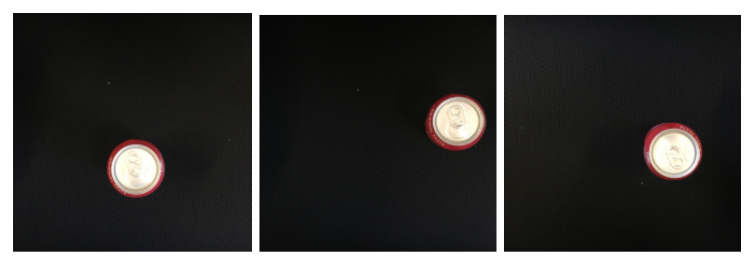
The most adequate output for a network to do the required task is $y=[p_{c},b_{x},b_{y},b_{h},b_{w},c_{1}]$ (Which of the following do you agree with the most?)
True, $p_{c}$ indicates the presence of an object of interest, $b_{x},b_{y},b_{h},b_{w}$ indicate the position of the object and its bounding box, and $c_{1}$ the probability of there being a can of soft-drink.
True, since this is a localization problem.
False, since we only need two values $c_{1}$ for soft-drink can.
False, we don't need $b_{h}$ since the cans are all the same size.
Try again
Notice that $p_{c}$ and $c_{1}$ have the same function in this case.
0 / 1 point

Question 3
When building a neural network that inputs a picture of a person's face and outputs N landmarks on the face (assume that the input image contains exactly one face), we need two coordinates for each landmark, thus we need 2N output units. True/False?

True
Nice work
Correct. Recall that each landmark is a specific position in the face's image, thus we need to specify two coordinates for each landmark.
1 / 1 point

Question 4
You are working to create an object detection system, like the ones described in the lectures, to locate cats in a room. To have more data with which to train, you search on the internet and find a large number of cat photos.
Which of the following is true about the system?
We should add the internet images (without the presence of bounding boxes in them) to the train set.
We should use the internet images in the dev and test set since we don't have bounding boxes.
We can't use internet images because it changes the distribution of the dataset.
We can't add the internet images unless they have bounding boxes.
Try again
We can't use just any image to measure the dev error, we also need to have bounding boxes.
0 / 1 point

Question 5
What is the IoU between the red box and the blue box in the following figure? Assume that all the squares have the same measurements.
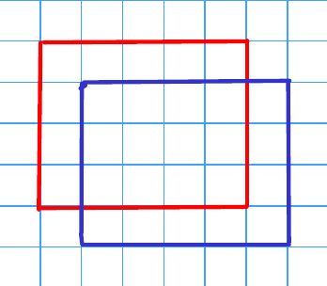
$$\frac{3}{7}$$
Nice work
Correct. IoU is calculated as the quotient of the area of the intersection (16) over the area of the union (28).
1 / 1 point

Question 6
Suppose you run non-max suppression on the predicted boxes below. The parameters you use for non-max suppression are that boxes with probability $≤0.4$ are discarded, and the IoU threshold for deciding if two boxes overlap is $0.5$.
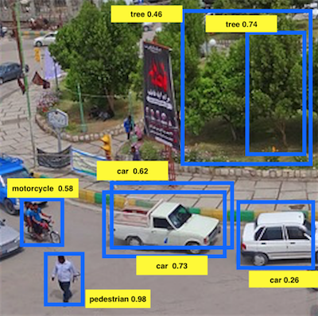
Notice that there are three bounding boxes for cars. After running non-max suppression, only the bounding box of the car with 0.73 is kept from the three bounding boxes for cars. True/False? Choose the best answer.
True. The non-maximum suppression eliminates the bounding boxes with scores lower than the ones of the maximum.
Nice work
Correct. The bounding box for the car on the right is eliminated because its probability is less than 0.4. Of the two bounding boxes in the middle, one is eliminated because their IoU is higher than 0.5. So, only one (with score 0.73) bounding box remains.
1 / 1 point

Question 7
Suppose you are using YOLO on a 19x19 grid, on a detection problem with 20 classes, and with 5 anchor boxes. During training, for each image you will need to construct an output volume $y$ as the target value for the neural network; this corresponds to the last layer of the neural network. ($y$ may include some “?”, or “don’t cares”). What is the dimension of this output volume?
19x19x(5x25)
Nice work
Correct, you get a 19x19 grid where each cell encodes information about 5 boxes and each box is defined by a confidence probability ($p_{c}$), 4 coordinates ($b_{x},b_{y},b_{h},b_{w}$) and classes ($c_{1},...,c_{20}$).
1 / 1 point

Question 8
Semantic segmentation can only be applied to classify pixels of images in a binary way as 1 or 0, according to whether they belong to a certain class or not. True/False?
False

Nice work
Correct. The same ideas used for multi-class classification can be applied to semantic segmentation.
1 / 1 point

Question 9
Using the concept of Transpose Convolution, fill in the values of X, Y and Z below.
(padding = 1, stride = 2)
Input: 2x2
1 | 2
3 | 4
Filter: 3x3
1 | 0 | -1
1 | 0 | -1
1 | 0 | -1
Result: 6x6
 | 0 | 1 | 0 | -2
 | 0 | X | 0 | Y
 | 0 | 1 | 0 | Z
 | 0 | 1 | 0 | -4
X = 2, Y = -6, Z = -4
Nice work
1 / 1 point

10.
Question 10
Suppose your input to a U-Net architecture is $h$h x $w$w x $3$3, where 3 denotes your number of channels (RGB). What will be the dimension of your output ?
$h$ x $w$ x $n$, where n = number of output classes
Nice work

WEEK 4

Clarifications about Upcoming Face Verification and Binary Classification Video
0:11/0:12
At 2:08, Andrew should have written $w_{k}$, instead of $w_{i}$.
So the formula should be:

$$y_{hat}=σ\left(\sum_{k=1}^{128}{w_{k}}∣f(x^{\left(i\right)})_{k}-f(x^{\left(j\right)})_{k}∣+b\right)$$

Clarifications about Upcoming Style Cost Function Video
0:45/0:46
Please note that in the next video at around 8:50 when Andrew wrote down the second formula of matrix, the second factor of the multiplication should be on index k' (k prime), not k (otherwise it does not calculate any kind of covariance). This is shown in black below.
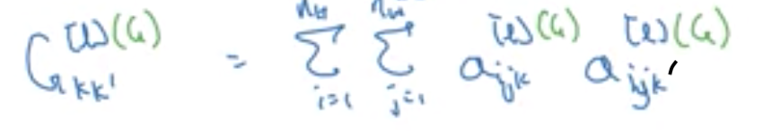
So the formula should be:

$$G_{kk^{'}}^{[l](G)}=\sum_{i=1}^{n_{H}}{\sum_{j=1}^{n_{W}}{a_{i,j,k}^{[l](G)}}}a_{i,j,k^{'}}^{[l](G)}$$
Also at 11:08 the style cost function formula should be the squared difference:

$${\left(G_{S}-G_{G}\right)}^{2}$$
instead of just the difference:

$$\left(G_{S} − G_{G}\right)$$
The style cost function should be:

$$J_{style}^{\left[l\right]}(S,G)=\frac{1}{{\left(2n_{H}^{\left[l\right]}n_{W}^{\left[l\right]}n_{C}^{\left[l\right]}\right)}^{2}}\sum_{k}{\sum_{k^{'}}{{\left(G_{kk^{'}}^{[l](S)} − G_{kk^{'}}^{[l](G)}\right)}^{2}}}$$

WEEK 4 QUIZ:
Question 1
Which of the following do you agree with?
Face recognition requires K comparisons of a person's face.
Nice work
Correct, in face recognition we compare the face of one person to K to classify the face as one of those K or not.
1 / 1 point

Question 2
Why is the face verification problem considered a one-shot learning problem? Choose the best answer.
Because we might have only one example of the person we want to verify.
Nice work
Correct. One-shot learning refers to the amount of data we have to solve a task.
1 / 1 point

Question 3
You want to build a system that receives a person's face picture and determines if the person is inside a workgroup. You have pictures of all the faces of the people currently in the workgroup, but some members might leave, and some new members might be added. To train a system to solve this problem using the triplet loss you must collect pictures of different faces from only the current members of the team. True/False?
False
Nice work
Correct. Although it is necessary to have several pictures of the same person, it is not absolutely necessary that all the pictures only come from current members of the team.
1 / 1 point

4.
Question 4
Which of the following is a correct definition of the triplet loss? Consider that $α>0$. (We encourage you to figure out the answer from first principles, rather than just refer to the lecture.)
$$max(∣∣f(A)-f(P)∣∣^{2}-∣∣f(A)-f(N)∣∣^{2}+α,0)$$
Nice work
Correct
1 / 1 point

Question 5
Consider the following Siamese network architecture:
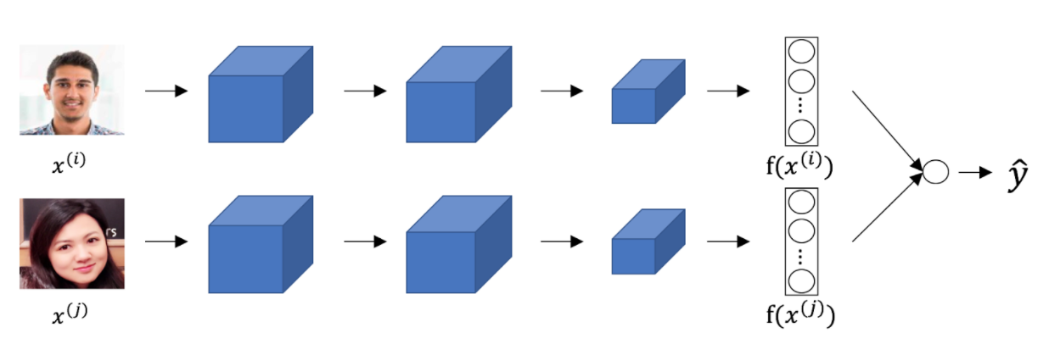
The upper and lower networks share parameters to have a consistent encoding for both images. True/False?
True

Nice work
Correct. Part of the idea behind the Siamese network is to compare the encoding of the images, thus they must be consistent.
1 / 1 point

Question 6
You train a ConvNet on a dataset with 100 different classes. You wonder if you can find a hidden unit which responds strongly to pictures of cats. (I.e., a neuron so that, of all the input/training images that strongly activate that neuron, the majority are cat pictures.) You are more likely to find this unit in layer 4 of the network than in layer 1.
True

Nice work
Yes, this neuron understands complex shapes (cat pictures) so it is more likely to be in a deeper layer than in the first layer.
1 / 1 point

Question 7
Neural style transfer is trained as a supervised learning task in which the goal is to input two images ($x$), and train a network to output a new, synthesized image ($y$).
False
Nice work
Yes, Neural style transfer is about training the pixels of an image to make it look artistic, it is not learning any parameters.
1 / 1 point

Question 8
In neural style transfer, we define style as:
${∥a^{[l](S)}-a^{[l](G)}∥}^{2}$, the distance between the activation of the style image and the content image.
The correlation between the generated image $G$ and the style image $S$.
The correlation between the activation of the content image $C$ and the style image $S$.
The correlation between activations across channels of an image.
Try again
No, the style is defined as the correlation between activations across channels of the activation of an image.
0 / 1 point

Question 9
In neural style transfer, we can't use gradient descent since there are no trainable parameters. True/False?
False

Nice work
Correct. We use gradient descent on the cost function $J(G)$ and we update the pixel values of the generated image $G$.
1 / 1 point

Question 10
You are working with 3D data. The input "image" has size $32×32×32×3$, if you apply a convolutional layer with 16 filters of size $4×4×4$ padding and stride 1. What is the size of the output volume?
$$29×29×29×16$$
Nice work
Correct, we can use the formula $⌊\frac{n^{\left[l − 1\right]}-f+2×p}{s}⌋+1=n^{\left[l\right]}$ on the three first dimensions.

